InteGRITy Part 5
Relational Integrity
Week of 11.27.16 | Talk It Over Discussion Guide

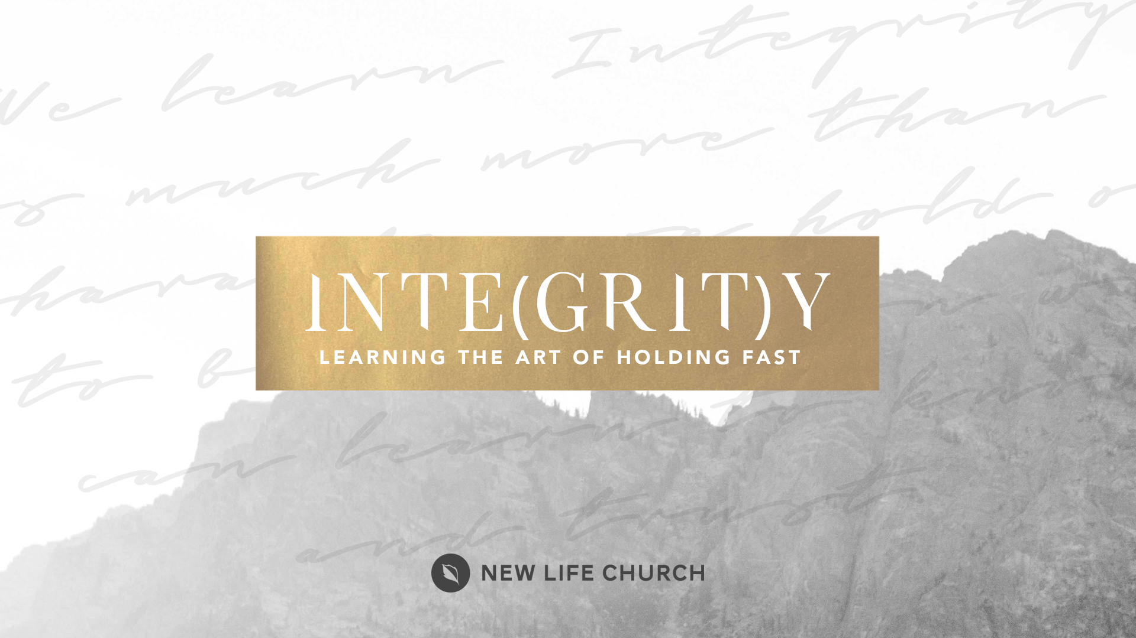
Talking through the message during the week and in the Life Group context helps you turn what God is saying to you into action steps. These discussion points, questions, and scriptures are designed to help you take the next step. If you’re leading a group through this guide, don’t feel like you have to answer every question. Pick out those questions that will stir up conversation and action among your group.

Watch Part 5 on New Life’s YouTube Channel.

Opener: What is farthest you have travelled for Thanksgiving? What special family tradition(s) do you have?

Read Ezekiel 36:26, Jeremiah 31:33, Col 3:13-14, Genesis 39:7-12, I Cor 15:33, Daniel 1:8 Acts 27:25-26, Galatians 5:22-26
- Whole people care about their relationships being whole. Forgiveness is the key (and it takes grit).
  - Why do you think the Bible says to forgive quickly and completely?
  - How have you personally grown in forgiveness in your life? Both asking for forgiveness and releasing forgiveness.
- Integrity embraces boundaries against unhealthy relationships.
  - How do you think Joseph able to maintain his integrity living in Egypt?
  - How can you apply some of those lessons in your life?
- Godly relationships strengthen personal integrity. What is influencing you?
  - Who are the gritty people in your life and have they influenced you for godliness? (iron sharpens iron)

Prayer Response Have a time of prayer ministry in response to what was shared in the discussion.

