Foolproof Part 5
Week of 10.04.15 | Talk It Over Discussion Guide

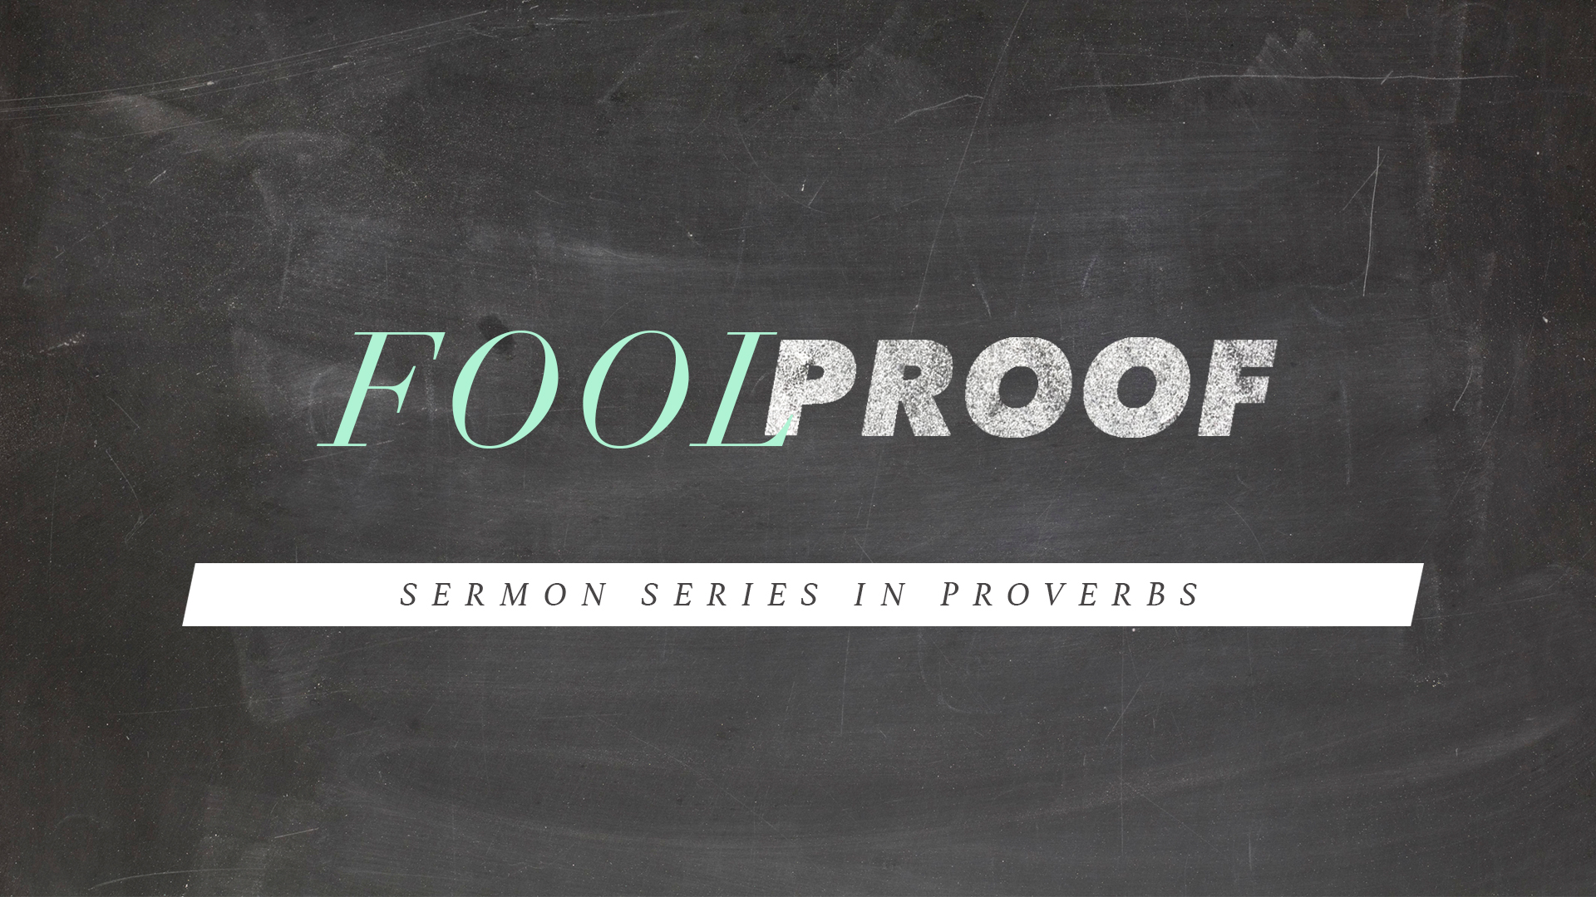
Talking through the message during the week and in the Life Group context helps you turn what God is saying to you into action steps. These discussion points, questions, and scriptures are designed to help you take the next step. If you’re leading a group through this guide, don’t feel like you have to answer every question. Pick out those questions that will stir up conversation and action among your group.

Catch up on FoolProof on New Life’s YouTube Channel.

Opener – 1) Share about foolish thing that you did as a child or as a teenager that has turned out to be learning experience or a life lesson. 2) Have you ever learned from someone else’s foolish mistakes on what not to do? If yes explain your answer.

Week 5 – The “Steadfast Fool”. - Nabal –which means “stupid, wicked,”. Elsewhere in the Old Testament, nâbâl also is translated as vile person.
Read Daniel Psalm 14:1, James 4:6, Proverbs 9:9,
A steadfast fool totally rejects God and His ways. This type of fool is self-confident and close-minded. He is his own god, freely gratifying his lower nature. It is his goal to draw as many others as possible into his evil.

- If the Steadfast fool has said in his heart that there is no God, what would be the implications and consequences of such a decision?
- Explain James 4:6 in your own words? How would you define pride and humility?
- Proverbs 9:9 speaks of giving instructing to a wise man. Does this verse change or challenge your understanding of wisdom? Explain your answer.
- Who if anyone speaks into your life right now? Have would you grade yourself from 1-10 about receiving input and criticism. (1- being not able to receive from anyone and 10- being able to receive from everyone)

We defined Wisdom – As the skill to live life according to God’s plan.
How do we determine God’s plan for our lives. These 5 C.S.’s can help us navigate. Read and discuss the following points. Close by praying for clarity and confirmation of God’s plan for one another.
5 C.S.’s on God’s Guidance
- Commanding Scripture - 2 Timothy 3:16-17
- Compelling Spirit - Luke 4:1
- Common Sense - Proverbs 2:7-11
- Counsel of the saints - Proverbs 11:14
- Circumstantial signs

