Born Identity
Week of 2.21.16 | Talk It Over Discussion Guide

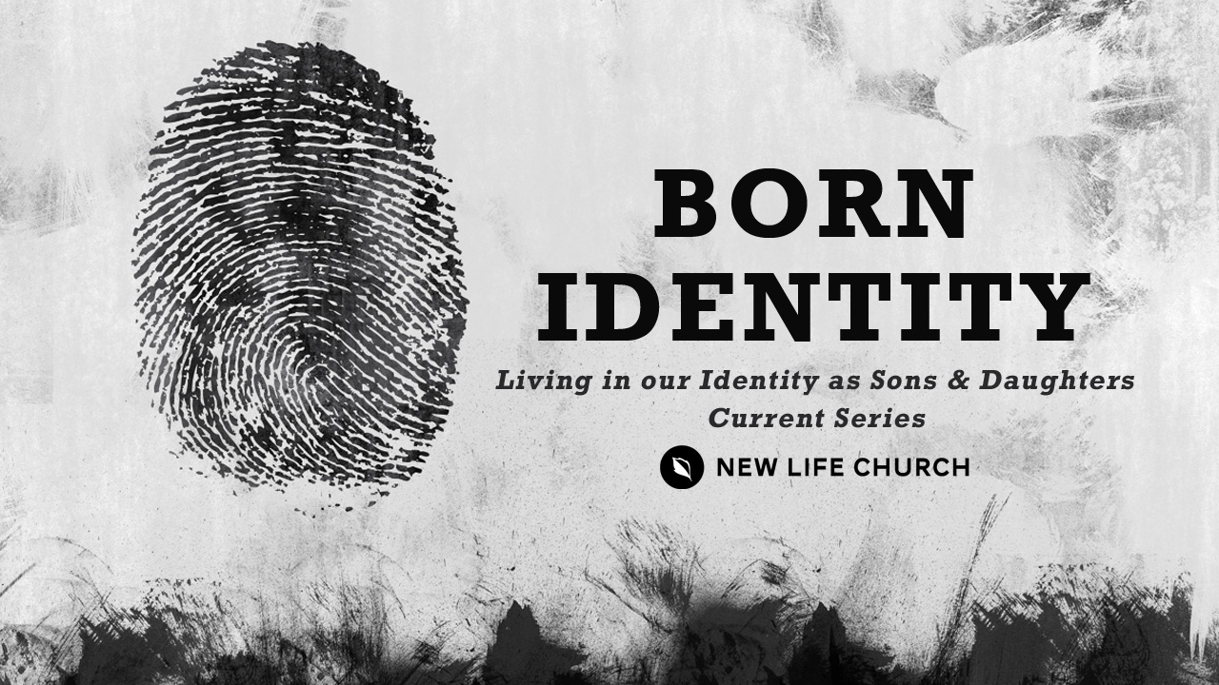
Talking through the message during the week and in the Life Group context helps you turn what God is saying to you into action steps. These discussion points, questions, and scriptures are designed to help you take the next step. If you’re leading a group through this guide, don’t feel like you have to answer every question. Pick out those questions that will stir up conversation and action among your group.

Watch Born Identity Part 1 on New Life’s YouTube Channel.

Opener – Have you ever had your identity stolen? Lost your identification? Talk about the experience.

- Read II Corinthians 5:17
- What does it mean to be “in Christ”?
- Discuss “old things have passed away, all things have become new.
- Read II Corinthians 6:16 & Matthew 3:16-17.
- The world tells us “you are what you do”, but the Matthew 3:17 statement was made by the Father over Jesus before he ever did a single miracle. What does that teach us?
- You are a beloved son/daughter, who brings the Father great joy. Is this truth easy or difficult for you to receive? Why?
- How do you see God seeing you?
- Read John 10:10, Matthew 4:1-6
- Jesus’ identity was immediately questioned after the Father spoke over him in Matthew 3. How has the thief attempted to identity theft in your life?
- Discuss this statement: “a lie believed as truth will affect you as if it were true.”
- Read Matthew 4:4, 7, & 10 – “It is Written”
- We overcome by standing on the word of God and being strengthened by the Holy Spirit. Share a personally example of this from your life
- What does it mean to declare “It is written”? Where do you need to stand on the word of God in your life?

Prayer Response Have a time of prayer ministry in response to what was shared in the discussion.

