InteGRITy Part 4
You’re Gonna Make It
Week of 11.20.16 | Talk It Over Discussion Guide

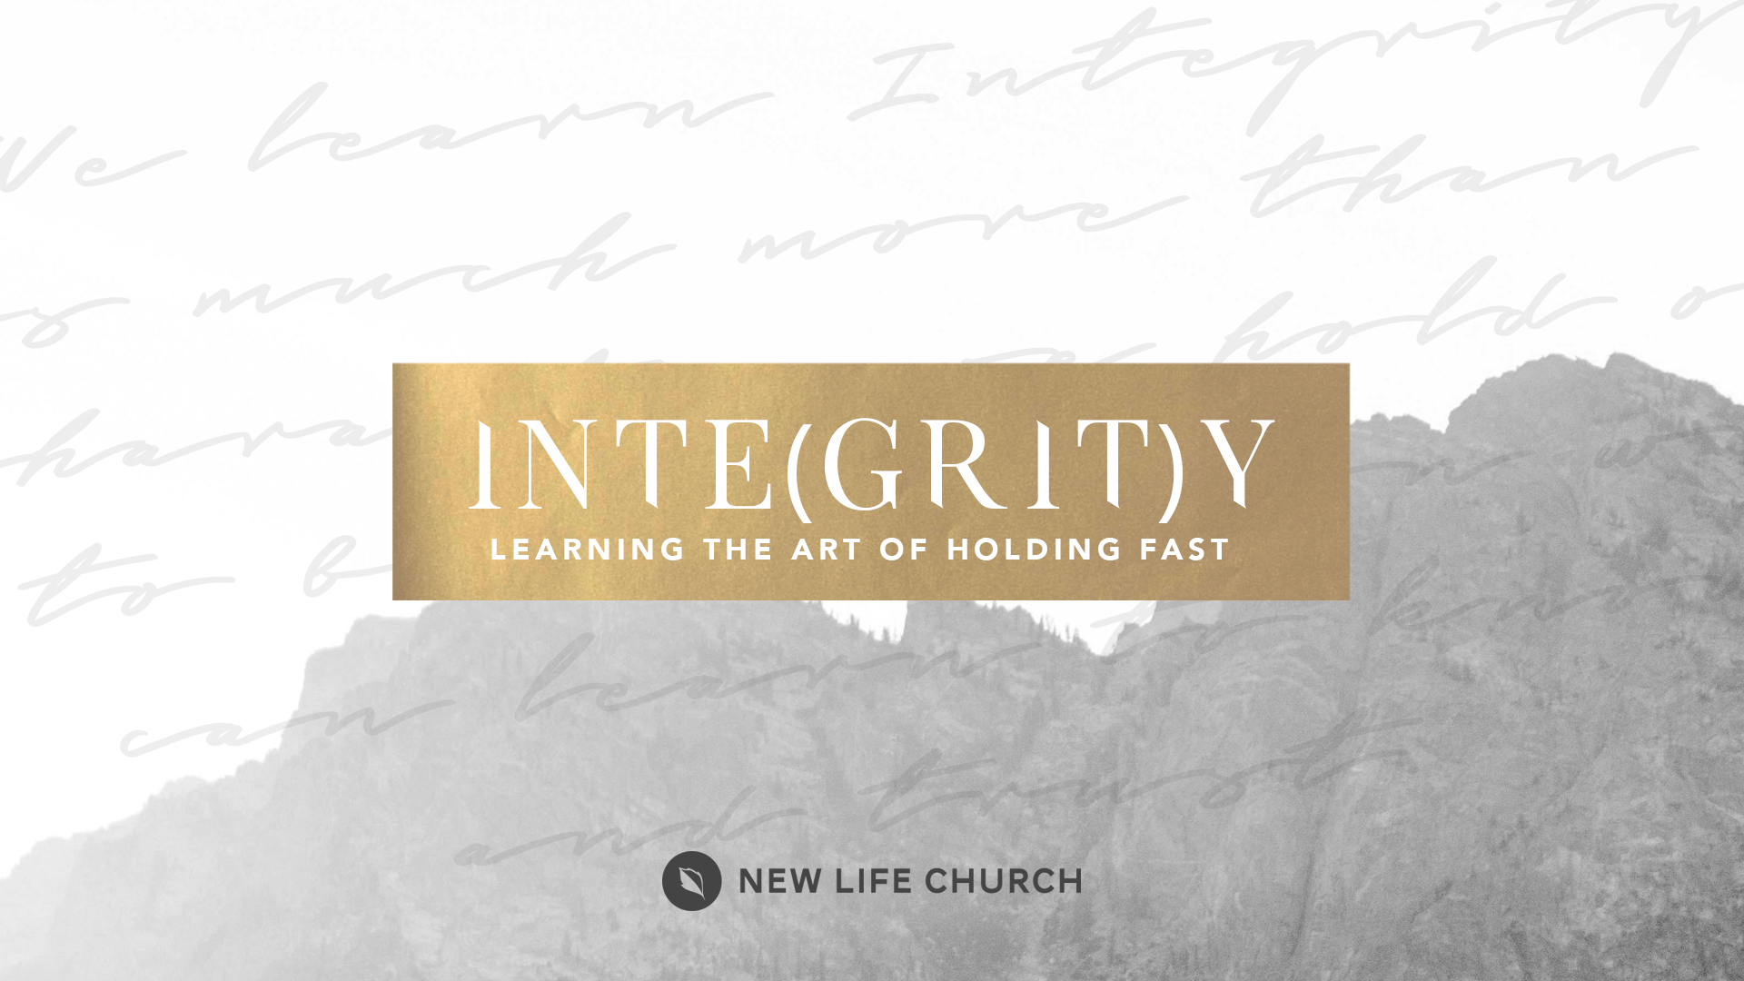
Talking through the message during the week and in the Life Group context helps you turn what God is saying to you into action steps. These discussion points, questions, and scriptures are designed to help you take the next step. If you’re leading a group through this guide, don’t feel like you have to answer every question. Pick out those questions that will stir up conversation and action among your group.

Watch Part 4 on New Life’s YouTube Channel.

Opener: What is the longest time you spent on a boat? Briefly explain where you went and what the weather and ocean conditions were like.

Read Acts 27:39-44, I Peter 4:12, Acts 27:25-26,
- What was your main take away from Pastor Andrev’s message?
- Do you agree with the statement that the “journey may be rough” in describing our walk with Jesus in fulfilling our purpose and calling? Explain your answer.
- The Apostle Paul found favor during the storm from the centurion, how has the “Favor of God” shown up in the midst of your storm?
- Explain Grit in your own words.
- Pastor Andrev was talking about cutting the anchors and losing cargo as part of his own personal journey with the Lord. How can you relate to these concepts in your own journey?
- When the ship ran aground, the centurion commanded those who could swim to jump out of the boat and swim for shore, he then commanded those who couldn't swim to grab some boards from the breaking ship and cling to them to help them make it to shore. Pastor Andrev said they not only had cling to the boards but that we had to paddle as well. Explain what that means to you?
Prayer Response Have a time of prayer ministry in response to what was shared in the discussion.

