Born Identity – Growing Up in the House
Week of 3.20.16 | Talk It Over Discussion Guide

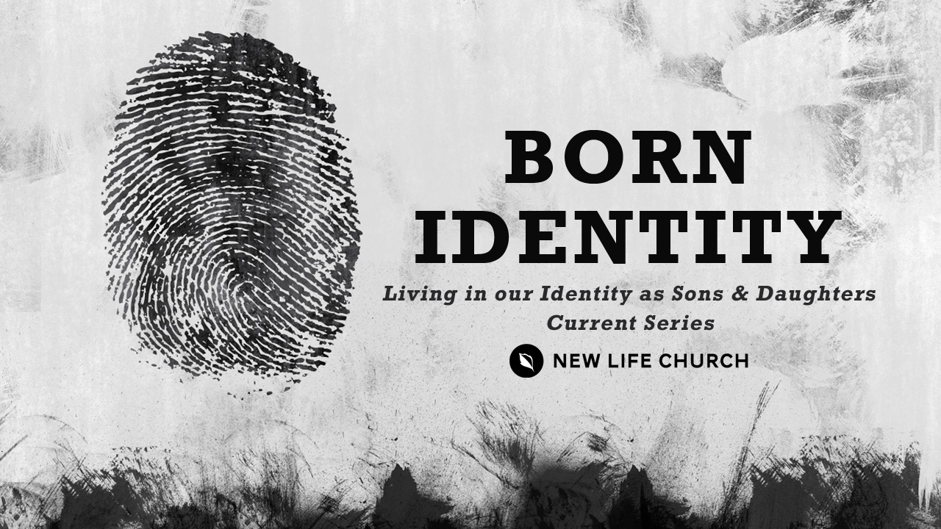
Talking through the message during the week and in the Life Group context helps you turn what God is saying to you into action steps. These discussion points, questions, and scriptures are designed to help you take the next step. If you’re leading a group through this guide, don’t feel like you have to answer every question. Pick out those questions that will stir up conversation and action among your group.

Watch Born Identify part 5 on New Life’s YouTube Channel.

Opener – Did you grow up with any siblings? If yes, what kind of things did you compete against each other for? For example, in my family, we used to all want the banana that had the sticker on it. We also had a stiff competition for calling “shotgun” which meant that we earned the right to ride in the front seat of the vehicle.

- Read Ephesians 5:1, Ephesians 4:13-15,
- Describe in your words what it means to be “an imitator of God as dear children”.
- How do you think we actually “grow up into all things into Him who is Christ”?
- Why do you think the scripture tells us to “childlike” but not be “childish”?
- Read Luke 15:11-24
- How can you relate to the younger brother in this parable?
- Have you ever had one of the moments where you “came to yourself”?
- Describe how the Father’s response to the younger son speaks to you personally about our Heavenly Father’s love?
- Read Luke 15:25-32
- Do you think the older brothers anger was justified? Why or why not?
- What do you think this older brother biggest issue was?
- Have you ever been envious over someone else’s promotion, success or good fortune and do you think seeing yourself as a son or daughter can help you overcome these negative feelings?

Prayer Response Have a time of prayer ministry in response to what was shared in the discussion.

