Born Identity - Labels
Week of 3.6.16 | Talk It Over Discussion Guide

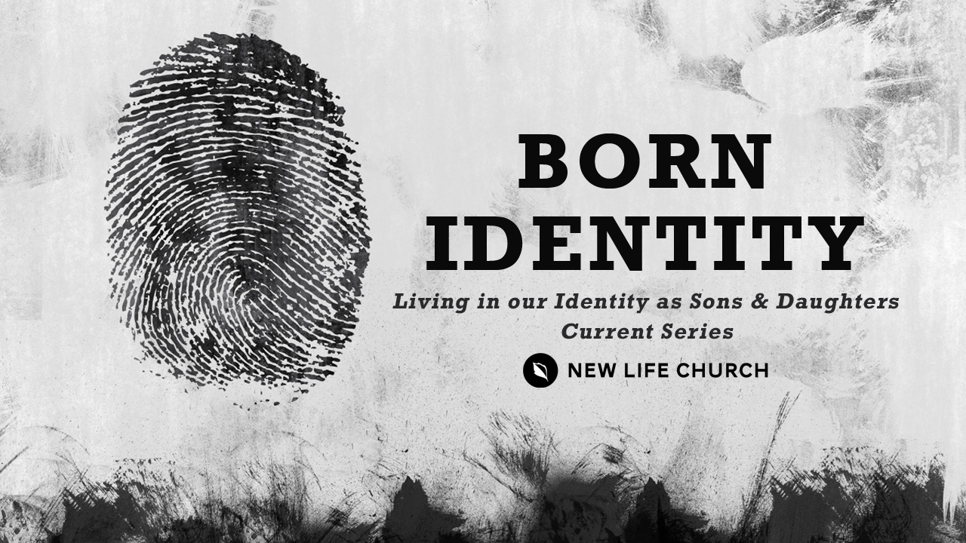
Talking through the message during the week and in the Life Group context helps you turn what God is saying to you into action steps. These discussion points, questions, and scriptures are designed to help you take the next step. If you’re leading a group through this guide, don’t feel like you have to answer every question. Pick out those questions that will stir up conversation and action among your group.

Watch Born Identity Part 3 on New Life’s YouTube Channel.

Opener – Share nickname that you were called growing up. Who gave it to you? Why is it special (or annoying ).

- Read Proverbs 18:21, James 3:6, & Romans 1:7.
- Labels create expectations. Discuss how a label can become a self-fulfilling prophecy.
- “We will mistreat what we misdiagnose.” What does this statement mean to you?
- How does it feel when you’ve been labeled? Have you had a positive labeling experience? How did it affect you?
- Read I Peter 2:9-10, Isaiah 62:2,4, & 12
- You’ve been called by a new name. You are not who you were. What is the difference between the past and the present in I Peter 2:9-10?
- What “labels” does God give us in those verses?
- What labels have been given to you that weren’t from God? (Can lead to ministry time at the end.)
- Meditate on the phrase “no longer be termed”. What does that mean to you?
- Read Acts 28:3-5, II Cor. 5:17, & I Cor. 6:11
- We must each choose to embrace and live in our new names. How did Paul do that in Acts 28?
- Discuss this point: “Don't let the viper's poison get into your thinking and confuse what is with what was.” How does the Bible say about this distinction?
- Paul shook off the viper and suffered no harm. Discuss this in relationship to labels and identity.

Prayer Response Have a time of prayer ministry in response to what was shared in the discussion.

